3. SYSTEM DESIGN
3.1 Data Design:
Databases explore how to use relationship in a pool of data when developing methods for data storage and retrieval. Databases allow data to be shared among different applications.
Entity Relationship Diagram:
Entity relationship analysis uses three major abstractions to describe data. These are
- Entities, which are distinct things in the enterprise.
- Relationships, which are meaningful interactions between the objects.
- Attributes, which are the properties of the entities and relationship.
The relative simplicity and pictorial clarity of this diagramming technique May well account in large part for the widespread use of ER model. Such a diagram consists of the following major components.
Mapping Constraints
An E-R diagram may define certain constraints which the contents of a database must conform.
Mapping Cardinalities
It expresses the number of entities to which another entity can be associated via a relationship. For binary relationship sets between entity sets A and B, the mapping cardinality must be one of the following.
One-to-One – An entity in A is associated with at most one entity in B, and an entity in B is associated with at most one entity in A.
One-to-many – An entity in A is associated with any number in B. An entity in B is associated with any number in A.
Many-to-many – Entities in A and B are associated with any number from each other.
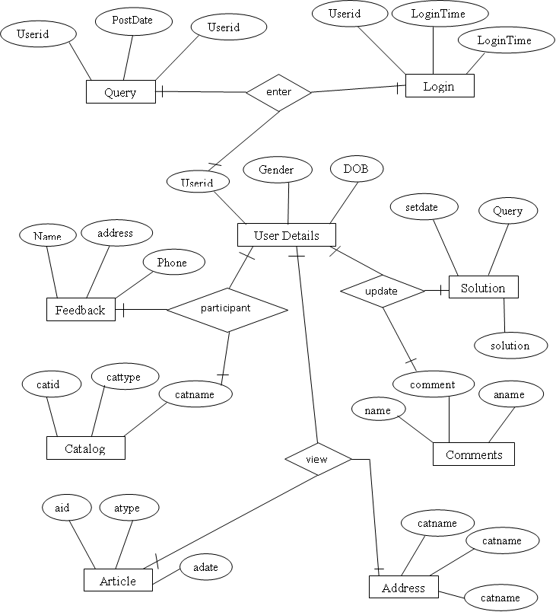
Fig 3.1.1: ER-Diagram For All Project
3.2. Data Dictionary
Data dictionary consists of descriptions of all the data used in the system. It consists of logical characteristic of current systems data stores including name, description, aliases, contents and organization. Data dictionary serves as basis for identifying databases requirements during requirements during system design. Data dictionary is a catalog a repository of the elements in the system. The Data dictionary is used to manage the detail in large systems, to communicate a common meaning for all system elements, to document the features of the system elements, to document the feature of the system, to locate errors and omissions in the system.
Data dictionary contains two types of description, the data flowing through the system. One is Data element and the other is Data structure. The most fundamental level is the data element. Data Structure is a set of data items data related to one another and collectively describe a component in the system. The description of the data elements consists of data names, data description, aliases, and length and data values. The description of data structure consists of sequence relationship, selection, Iteration relationship and option relationship. Tables are part of Data Dictionary.
Fig 3.3.2: Class Diagram for Overall project
Interaction Diagrams Table name: USERS
Description: The below table have a user login details. In this table userid is primary key. If the user try to login this table is validate the user.

COLUMN NAME | DATA TYPE & SIZE | CONSTRAINT
USERID | VARCHAR(20) | PRIMARY KEY
PASSWORD | VARCHAR(20) | NOT NULL
TYPEOFUSER | VARCHAR(10) | NOT NULL
Table 3.2.1: USERS
Table Name: COURSEDETAILS
Description: The below table have the all details of course activities information.

COLUMN NAME | DATA TYPE & SIZE | CONSTRAINT
COURSEID | VARCHAR(20) | PRIMARY KEY
DOL | DATE | NOT NULL
CHAPTER | VARCHAR(30) | NOT NULL
FILENAME | VARCHAR(100) | NOT NULL
Table 3.2.2: COURSEDETAILS
Table name: COURSE
Description: The below table have the course details activities information. In this table CourseID are primary key to avoiding duplicate CourseID’s.

COLUMN NAME | DATA TYPE & SIZE | CONSTRAINT
COURSEID | VARCHAR(20) | PRIMARY KEY
COURSE | VARCHAR(30) | NOT NULL
DURATION | NUMBER(5) | NOT NULL
FEES | NUMBER(5) | NOT NULL
STATUS | VARCHAR(1) | NOT NULL
Table 3.2.3: COURSE
Table Name: COURSEHTML
Description: The below table have the all details of course activities information and also uploading of topic and notes.

COLUMN NAME | DATA TYPE & SIZE | CONSTRAINT
COURSEID | VARCHAR(20) | PRIMARY KEY
DOL | DATE | NOT NULL
CHAPTER | VARCHAR(30) | NOT NULL
TOPIC | VARCHAR(30) | NOT NULL
NOTES | VARCHAR(4000) | NOT NULL
Table 3.2.4: COURSEHTML

Table Name: SETEXAM
Description: The below table helps to set the exam

COLUMN NAME | DATA TYPE & SIZE | CONSTRAINT
EXTYPE | NUMBER(1) | PRIMARY KEY
Table 3.2.5: SETEXAM
Table Name: ADMIN_INBOX
Description: The below table have a user all the users activities information. In this table MID are primary key to avoiding duplicate MID’s.
.
COLUMN NAME | DATA TYPE & SIZE | CONSTRAINT
MID | NUMBER | PRIMARY KEY
USER_NAME | VARCHAR2(30) | NOT NULL
MSG_FROM | VARCHAR2(50) | NOT NULL
MSG_SUBJECT | VARCHAR2(50) | NOT NULL
MSG_DATA | VARCHAR2(1000) | NOT NULL
MSG_DATE | DATE | NOT NULL
Table 3.2.6: ADMIN_INBOX

Table Name: USER_INBOX
Description: The below table have a user all the users activities information. In this table MID are primary key to avoiding duplicate MID’s.

COLUMN NAME | DATA TYPE & SIZE | CONSTRAINT
MID | NUMBER | PRIMARY KEY
USER_NAME | VARCHAR2(30) | NOT NULL
MSG_FROM | VARCHAR2(50) | NOT NULL
MSG_SUBJECT | VARCHAR2(50) | NOT NULL
MSG_DATA | VARCHAR2(500) | NOT NULL
MSG_DATE | DATE | NOT NULL
Table 3.2.7: USER_INBOX
Table Name: MATCHQUES
Description: The below table have optional choice to choose as per user choice option. In this table QNO are primary key to avoiding duplicate QNO’s.

COLUMN NAME | DATA TYPE & SIZE | CONSTRAINT
QNO | NUMBER(10) | PRIMARY KEY
COURSE | VARCHAR(20) | NOT NULL
QUESTION | VARCHAR(150) | NOT NULL
OPTION1 | VARCHAR(100) | NOT NULL
OPTION2 | VARCHAR(100) | NOT NULL
OPTION3 | VARCHAR(100) | NOT NULL
OPTION4 | VARCHAR(100) | NOT NULL
ANSWER | VARCHAR(100) | NOT NULL
IMAGE | VARCHAR(50) | NOT NULL
Table 3.2.8: MATCHQUES
Table Name: FILLQUES
Description: The below table helps to set the questions and answers. In this table QNO are primary key to avoiding duplicate QNO’s.

COLUMN NAME | DATA TYPE & SIZE | CONSTRAINT
QNO | NUMBER(10) | PRIMARY KEY
COURSE | VARCHAR(20) | NOT NULL
QUESTION | VARCHAR(150) | NOT NULL
ANSWER | VARCHAR(100) | NOT NULL
IMAGE | VARCHAR(50) | NOT NULL
Table 3.2.9: FILLQUES
Table Name: EXAMPER
Description: The below table helps to declare the exam results. By this table we can able to know the fail or pass status and also students scored marks.

COLUMN NAME | DATA TYPE & SIZE | CONSTRAINT
CNO | NUMBER(10) | PRIMARY KEY
DOE | DATE | NOT NULL
COURSE | VARCHAR(20) | NOT NULL
STATUS | VARCHAR(1) | NOT NULL
RESULT | VARCHAR(10) | NOT NULL
MARKS | NUMBER(10) | NOT NULL
Table 3.2.10: EXAMPER

Table Name: REGISTRATION
Description: The below table have a registration details. In this table userid attribute is primary key because of avoiding duplicate userids.
.
COLUMN NAME | DATA TYPE & SIZE | CONSTRAINT
USERID | VARCHAR(20) | PRIMARY KEY
PASSWORD | VARCHAR(20) | NOT NULL
FNAME | VARCHAR(20) | NOT NULL
LNAME | VARCHAR(20) | NOT NULL
DOB | DATE | NOT NULL
DOJ | DATE | NOT NULL
SEX | CHAR(1) | NOT NULL
EDUCATION | VARCHAR(20) | NOT NULL
OCCUPATION | VARCHAR(40) | NOT NULL
ADDR | VARCHAR(20) | NOT NULL
STATE | VARCHAR(20) | NOT NULL
CITY | VARCHAR(20) | NOT NULL
COUNTRY | VARCHAR(20) | NOT NULL
ZIP | VARCHAR(10) | NOT NULL
PHONE | NUMBER(8) | NOT NULL
TELEPHONE | NUMBER(10) | NOT NULL
EMAIL | VARCHAR(30) | NOT NULL
JOINUSER | NUMBER(20) | NOT NULL
CNO | NUMBER(10) | NOT NULL
STATUS | CHAR(1) | NOT NULL
Table 3.2.11: REGISTRATION

Table Name: DDPAYMENT
Description: The below table have all details of payments. By this table we can also able to know status of payment and date of payment.

COLUMN NAME | DATA TYPE & SIZE | CONSTRAINT
CNO | NUMBER(10) | NOT NULL
USERID | VARCHAR(20) | PRIMARY KEY
DOD | DATE | NOT NULL
BANK | VARCHAR(20) | NOT NULL
DDNO | VARCHAR(20) | NOT NULL
AMT | NUMBER(10) | NOT NULL
STATUS | VARCHAR(1) | NOT NULL
Table 3.2.12: DDPAYMENT
Table Name: COURSEJOIN
Description: The below table helps in the selection of course. By this table we can able to know fees details and also course to learn.

COLUMN NAME | DATA TYPE & SIZE | CONSTRAINT
CNO | NUMBER(10) | NOT NULL
USERID | VARCHAR(20) | PRIMARY KEY
COURSE | VARCHAR(20) | NOT NULL
FEES | NUMBER(10) | NOT NULL
STATUS | CHAR(1) | NOT NULL
Table 3.2.13: COURSEJOIN

3.3. UML Design
The Unified Modeling language allows software engineer to express an analysis model using the modeling notation that is governed by set of syntactic semantic and pragmatic rules. A UML system is represented using five different views that describe the system from distinctly different perspective. Each view is defined by a set of diagram, which is as follows.
An Overview of UML
The Unified Modeling Language is a language for
- Visualizing.
- Specifying.
- Constructing.
- Documenting.
These are the artifacts of a software-intensive system.
User model view
- This view represents the system from the user’s perspective.
- The analysis representation describes a usage scenario from the end-users perspective.
Structural model view
- In this model the data and functionality are arrived from inside the system.
- This model view models the static structures.
Behavioral model view
It represents the dynamic of behavioral as parts of the system, depicting the interactions of collection between various structural elements described in the user model and structural model view.
Implementation model view
In this the structural and behavioral as parts of the system are represented as they are to be built.
Environmental model view
In this the structural and behavioral aspects of the environment in which the system is to be implemented are represented. UML is specifically constructed through two different domains they are
- UML Analysis modeling, this focuses on the user model and structural model views of the system.
- UML design modeling, which focuses on the behavioral modeling, implementation modeling and environmental model views.

A Conceptual model of UML
The three major elements of UML are
- The UML’s basic building blocks.
- The rules that dictate how those building blocks may be put together.
- Some common mechanisms that apply throughout the UML.

Basic building blocks of the UML

The vocabulary of UML encompasses three kinds of building blocks:
A. Things.
B. Relationships.
C. Diagrams.
A. Things
Things are the abstractions that are first-class citizens in a model. Relationships tie these things together. There are four kinds of things in the UML.
- Structural things.
- Behavioral things.
- Grouping things.
- Annotational things.

- Structural Things
Structural things are the nouns of the UML models. These are mostly static parts of the model, representing elements that are either conceptual or physical. In all, there are seven kinds of Structural things.
Class
A class is a description of a set of objects that share the same attributes, operations, relationships, and semantics. A class implements one or more interfaces. Graphically a class is rendered as a rectangle, usually including its name, attributes and operations, as shown below.
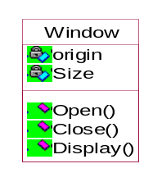
Sample Class Diagram
Interface
An interface is a collection of operations that specify a service of a class or component.
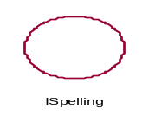
Collaboration
Collaboration defines an interaction and is a society of roles and other elements that work together to provide some cooperative behavior that’s bigger than the sum of all the elements.
Chain of Responsibility
Sample Collaboration Diagram

Use Case
Use case is a description of a set of sequence of actions that a system performs that yields an observable result of value to a particular things in a model. Graphically, Use Case is rendered as an ellipse with dashed lines, usually including only its name as shown below.
Place Order
Sample Use case diagram
Component
Component is a physical and replaceable part of a system that conforms to and provides the realization of a set of interfaces. Graphically, a component is rendered as a rectangle with tabs, usually including only its name, as shown below.
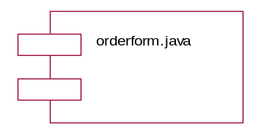
Sample Component Diagram
Node
A Node is a physical element that exists at run time and represents a computational resource, generally having at least some memory and often, processing capability. Graphically, a node is rendered as a cube, usually including only its name, as shown below.
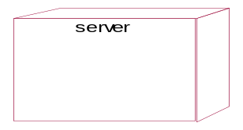
Sample Node Diagram

2. Behavioral Things
Behavioral Things are the dynamic parts of UML models. These are the verbs of a model, representing behavior over time and space.

Interaction

An interaction is a behavior that comprises a set of messages exchanged among a set of objects within a particular context to accomplish a specific purpose. Graphically, a message is rendered as a direct line, almost always including the name if its operation, as shown below.
Display
Sample Interaction Diagram
State Machine
A state machine is a behavior that specifies the sequence of states an object or an interaction goes through during its lifetime on response to events, together with its responses to those events. Graphically, a state is rendered as rounded rectangle usually including its name and its sub-states, if any, as shown below.

Waiting

Sample State Machine
3. Grouping Things
Grouping things are the organizational parts of the UML models. These are the boxes into which a model can be decomposed.

Package
A package is a general-purpose mechanism for organizing elements into groups.
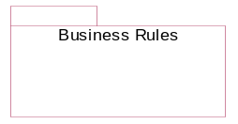
Sample Package Diagram
4. Annotational Things
Annotational things are the explanatory parts of the UML models.
Note
Graphically a note is rendered as a rectangle with dog-eared corner together, with a textual or graphical comment, as shown below.
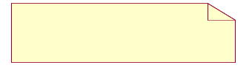
Sample Note Diagram
B. Relationships in the UML
There are four kinds of relationships in the UML
- Dependency.
- Association.
- Generalization.
- Realization.
C. Diagrams in the UML

State Chart Diagrams
A state chart diagram shows a state machine. State chart diagrams are used to model the dynamic aspects of the system. For the most part this involves modeling the behavior of the reactive objects. A reactive object is one whose behavior is best characterized by its response to events dispatched from outside its context. A reactive object has a clear lifeline whose current behavior is affected by its past.
A state chart diagram show a state machine emphasizing the flow of control from state to state. A state machine is a behavior that specifies the sequence of states an object goes through during its life time in response to events together with its response to those events.
Graphically a state chart diagram is a collection of vertices and arcs. State chart diagram commonly contain, Simple states and Composite states, transitions, including events and actions.
Deployment diagram
A deployment diagram is a diagram that shows the configuration of run time processing nodes and the components that live on them. Graphically, a deployment diagram is a collection of vertices and arcs.

Use Case Diagrams:

Use Case diagrams are one of the five diagrams in the UML for modeling the dynamic aspects of systems (activity diagrams, sequence diagrams, state chart diagrams and collaboration diagrams are the four other kinds of diagrams in the UML for modeling the dynamic aspects of systems). Use Case diagrams are central to modeling the behavior of the system, a sub-system, or a class. Each one shows a set of use cases and actors and relationships.

Contents

Use Case diagrams commonly contain Use Cases, Actors, Dependency, generalization, and association relationships like all other diagrams, use case diagrams may contain notes and constraints. Use Case diagrams may also contain packages, which are used to group elements of your model into larger chunks. Occasionally, you want to place instances of use cases in your diagrams, as well, especially when you want to visualize a specific executing system.
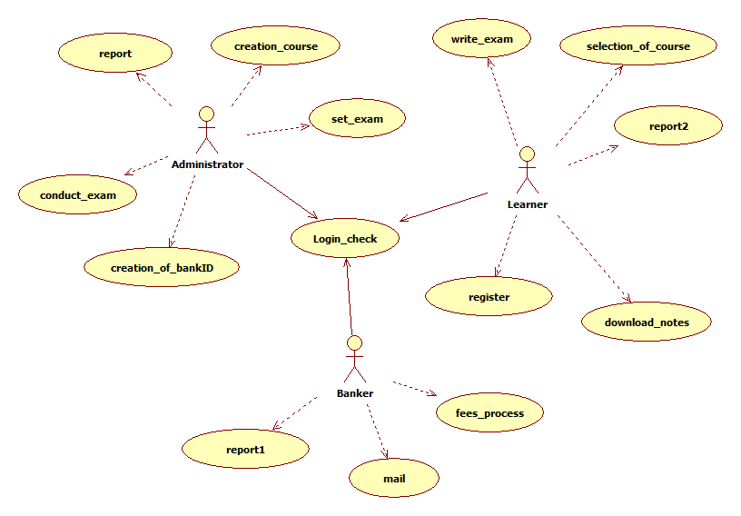
Fig 3.3.1: Use Case Diagram for Overall project

Class Diagrams:

Class diagrams are the most common diagrams found in modeling object-oriented systems. A class diagram shows a set of classes, interfaces, and collaborations and their relationships. Graphically, a class diagram is a collection of vertices and arcs.

Contents

Class Diagrams commonly contain Classes, Interfaces, and Collaborations, Dependency, Generalization and Association relationships.

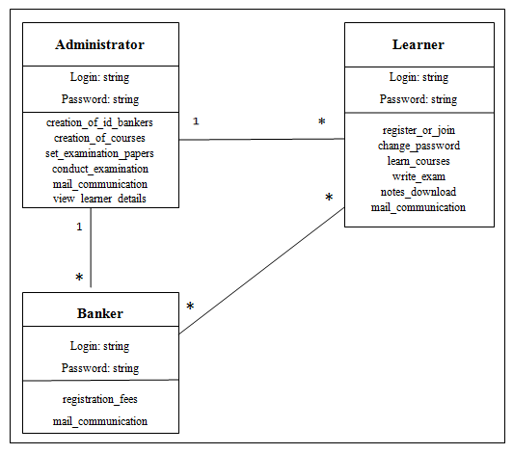

An Interaction diagram shows an interaction, consisting of a set of objects and their relationships, including the messages that may be dispatched among them. Interaction diagrams are used for modeling the dynamic aspects of the system.

Contents
Interaction diagrams commonly contain Objects, Links, and Messages. Like all other diagrams, interaction diagrams may contain notes and constraints.
Sequence Diagrams:
A sequence diagram is an interaction diagram that emphasizes the time ordering of the messages. Graphically, a sequence diagram is a table that shows objects arranged along the X-axis and messages, ordered in increasing time, along the Y-axis.
Typically you place the object that initiates the interaction at the left and increasingly more sub-routine objects to the right. Next, you place the messages that these objects send and receive along the Y-axis, in order of increasing time from top to the bottom.
Collaboration Diagrams:
A collaboration diagram is an interaction diagram that emphasizes the structural organization of the objects that send and receive messages.
A collaboration diagram emphasizes the organization of the objects that participate in an interaction. We form a collaboration diagram by first placing the objects that participate in the interaction as the vertices in a graph. Next, you render the links that connect these objects as the arcs of this graph. Finally, we adorn these links with the messages that objects send and receive.
New User Registration Sequence diagram:
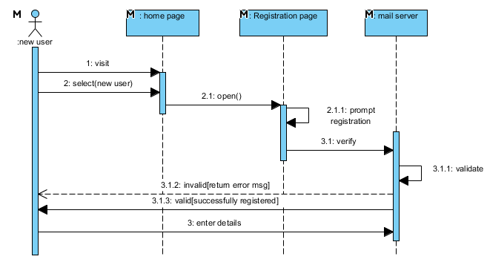
Fig 3.3.3: Sequence diagram for New User Registration.
Login Sequence diagram:
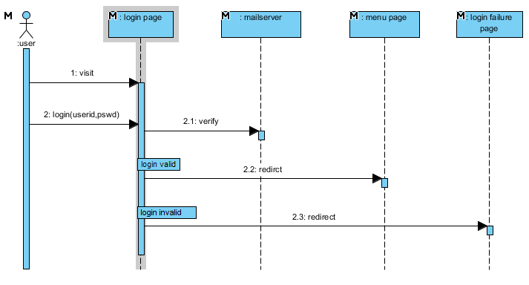

Fig 3.3.4: Sequence diagram for Login.

Forget password Sequence diagram:
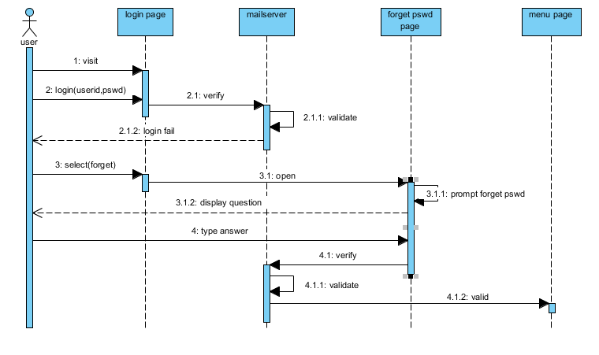
Fig 3.3.5: Sequence diagram for Forget password.

Compose Activity Sequence diagram:
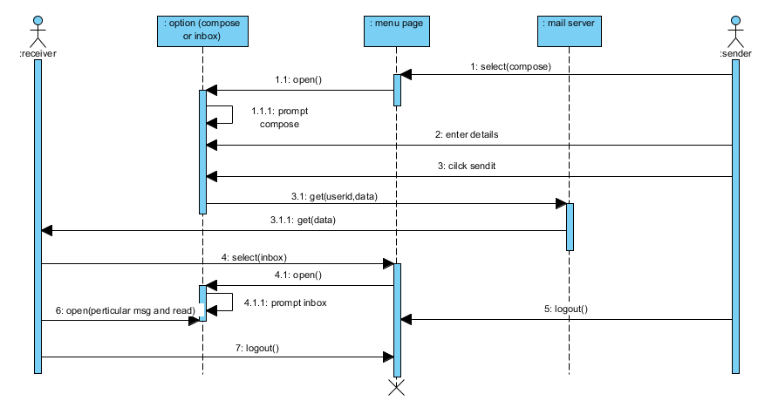
Fig 3.3.6: Sequence diagram for Compose Activity.

New User Registration Collaboration Diagram:
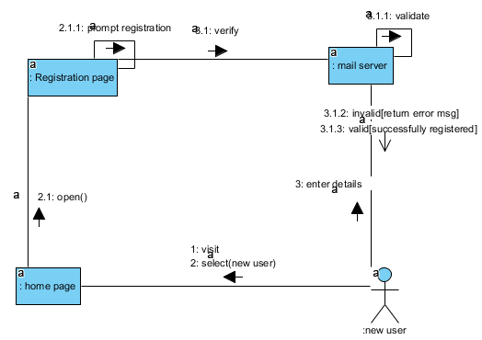
Fig 3.3.7: Collaboration Diagram for New User Registration

Login Collaboration Diagram:
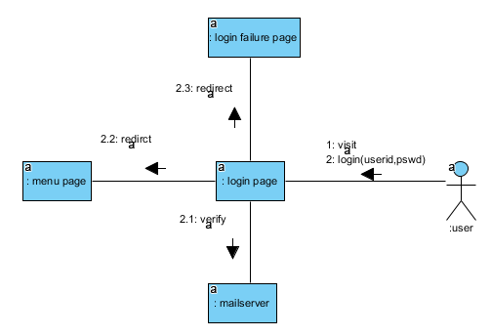
Fig 3.3.8: Collaboration Diagram for Login.

Forget Password Collaboration Diagram:
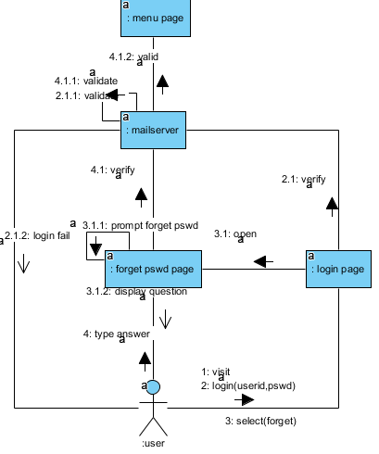
Fig 3.3.9: Collaboration Diagram for Forget Password.

Activity Diagram:
An Activity Diagram is essentially a flow chart showing flow of control from activity to activity. They are used to model the dynamic aspects of as system. They can also be used to model the flow of an object as it moves from state to state at different points in the flow of control.
An activity is an ongoing non-atomic execution with in a state machine. Activities ultimately result in some action, which is made up of executable atomic computations that result in a change of state of distinguishes a use case diagram from all other kinds of diagrams is its particular content

Registration Activity Diagram:
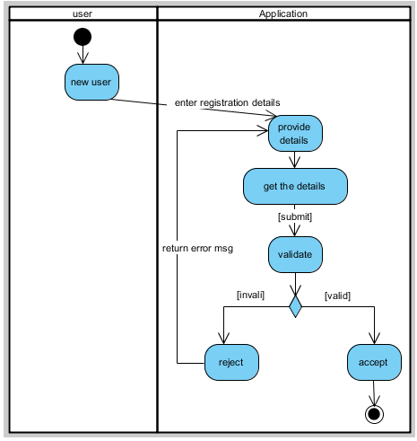
Fig 3.3.10: Activity Diagram for Registration

User login Activity Diagram:
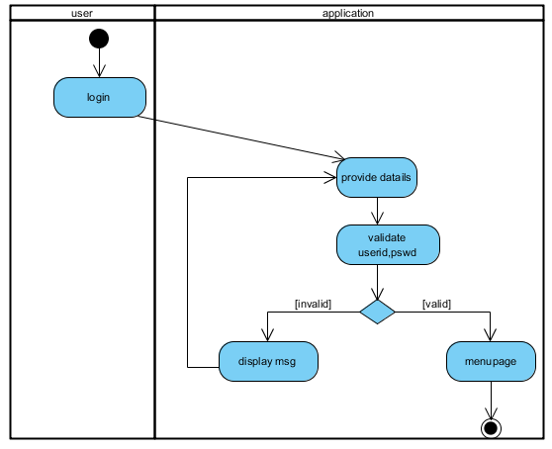
Fig 3.3.11: Activity Diagram for login

Administrator:
Fig 3.3.12 Activity Diagram for Administrator.
Admin
Login
Authentication
Home
StudentInfo
FacultyInfo
ModeratorInfo
FeedBacks
Security
Logout
AddModerator
ViewModerator
AddFaculty
ViewFaculty
AddStudent
ViewStudent
ViewFeedbacks
ChangePassword
If Success
if Fail
Deployment diagram:
A deployment diagram is a diagram that shows the configuration of run time processing nodes and the components that live on them. Graphically, a deployment diagram is a collection of vertices and arcs.
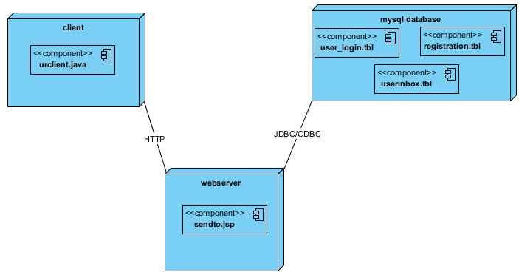
Fig 3.3.13: Deployment Diagram for overall project

